Program Case competition March 15 & 16 2023
Location: UC Limburg, Agoralaan, 3590 Diepenbeek
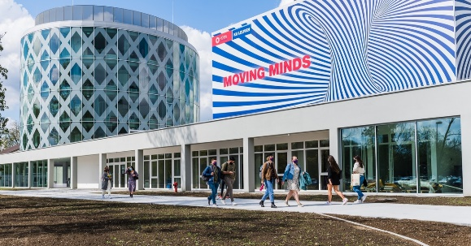
Wednesday March 15
• 9.00-9.10: Welcome
• 9.10-9.30: Agenda & meet your team
• 9.30-10.30: Ice-breaking session
• 10.30-11.00: Presentation of the challenges by the challenge owner(s)
• 11.00-11.30: Desk research
• 11.30–12.00: Creativity & brainstorming tips
• 12.00-13.00: Lunch & relax!
• 13.00–15.00: Brainstorming session
• 15.00-15.30: Coaching session
• 15.30-17.00: Business concept

Thursday March 16
• 9.00-9.30: 1’ Pitches
• 9.30-10.45: Group work – refine your business concept
• 10:45-11:00: How to pitch
• 11.00-12.00: Start preparing your pitch - Creative presentation of your idea
• 12.00–13.00: Lunch
• 13.15-14:30: The official Pitches
• 14:30-14:50: Announcement of winner
• 14:50: Kiss & goodbye

Tuesday March 14*
14.00-15.00: Guided tour @ Corda Campus, the largest technology and innovation campus in Europe
15.00-17.00: Workshop Softskills
In this workshop, we train the attitude behind important soft skills, for example: connecting, deep listening, creative thinking, risk-taking, team work, empathy, accepting and building on others’ ideas, etc. Using improvisation theatre methods, we dive into the mindset that can help us grow those skills. We use basic exercises that are beginner’s level, aiming to stimulate flow and growth for every participant in a comfortable way. All that’s expected from participants is an open mindset.
* Places for UCLL-students are limited – if you want to participate please send an e-mail to Karolien.Vlayen@ucll.be
Location: Kempische Steenweg 293/16, 3500 Hasselt
How to get there?
Buy your bus ticket

Practical information:

Coming from the airport:

Brussels Airport (Zaventem)
When you arrive at Brussels Airport you can travel to Hasselt by train. Depending on the time of day there is a direct railway connection between Brussels North Station and Hasselt. Shorter will be to take the train from Brussels Airport station directly to Leuven. And from there you continue to Hasselt.
Check the website of the Belgian railways to find all the up-to-date information you will need (passenger traffic services, time tables and prices).

Charleroi Airport ('Brussels-South')
Every 30 minutes a shuttle coach leaves the airport to drive to the main Brussels railway station (Brussels Midi). There you can take a (direct) train to Hasselt. http://www.b-rail.be

How to get to the campus of UCLL in Diepenbeek from Hasselt?
Our Diepenbeek Campus can be easily reached by bus, approximately 5 minutes from Hasselt. Line 45, 36, 20a, 11, 453 will take you there. The bus stop at the campus is Agoralaan, Diepenbeek. Buy your bus ticket here. More information on https://www.delijn.be/en/routeplanner/

